Project Proposal – Codinoc Cloud IDE

Computing Group Project [ Group **35** ]

***~ Mr. Pramudya Thilakarathne ~***



University of Plymouth, UK



NSBM Green University, LK

Table of Contents

Define the Problem 4

Solution for the Problem 5

Target Users 6

Project Features and Description 7

Key Features of IDE 7

Basic Features 7

Used Tools and Software 8

Platforms 8

Databases 8

Languages 8

Software 8

Libraries 8

Templates 8

Estimated Cost for the Project 9

Project Monitoring 10

Why we decided to use JetBrains YouTrack 10

Group Members and Workload 11

Leader Roles 11

Member Workload 11

Project Schedule 12

Acknowledgements 14

Abstract

In this era everything is connected with internet and anyone can't live without internet. And most of the internet is Web Sites and Pages. There are two types of web sites, Static and Dynamic. Static sites only have Front end and Dynamic sites have both front end and back end. So how web sites / pages are made? We need to use special programs for that. The first one is Programming Languages and second one is editors. There are so many languages available for web design and development such as JS, PHP, Ruby, HTML (Not a Programming Languages), CSS etc. In web application development anyone can use any type of Text editor, Code editor or an IDE. But there are have some Code Editors and IDEs like Sublime Text, Visual Studio Code, Brackets, JetBrains WebStorm, JetBrains PHPStorm and that Editors / IDEs comes with slew of useful and powerfull features such as Syntax Highlighting, Code Complement, Indentation, Brace Matching etc. However, creating websites is a difficult task and takes a long time. But if you build a website with a team, the difficulties in the development process will be less. And you need to use extra tools like GitHub, GitLab to that. So, from this project We'll introduce "Codinoc IDE" for complete your group projects without any difficulties. Codinoc IDE is a Cloud Based application and because of that any team can work remotely with our IDE using any operating system like Windows, Linux, Mac or iOS, Android. Our Cloud, Codinoc IDE is only for design Web Based Application such as Web Pages / Sites, Mobile Apps, Desktop Apps etc. Finally, our Cloud based IDE enables you to successfully combine the UI development processes in one application. The languages we supported mainly are HTML, CSS, JS and SCSS, SASS and LESS.

# Define the Problem

When a software is created by several people together rather than by one person, it can be done very quickly. That is because the development process of the relevant software can be shared with each other. This is an easy task in a company. This is because in a typical software development company, all the computers are interconnected so it can be done easily.

But suppose an ordinary team, not a company, does this. There, each other 's computers are not directly connected. Here you have to share the project related to the software created by the team.

Take a look at this example. Imagine that a team is developing a mobile app. Here are the basics: UI Design Process and App Development Process. For the UI design process, you can use online software such as Figma and Lunacy. But think about the app development process. How is it done? The project should be shared with each other.

Software such as Visual Studio provides Team support for this problem. But can everyone use it? Suppose I am a Linux User, another Mac User, another Windows User. Simply put, this is our problem.

# Solution for the Problem

Our primary objective is to find a solution to this problem. So we think the solution to this is to create a text editor that can be used by anyone or used by any team. After that, we hope to upgrade the Cloud Text Editor to a Cloud IDE (Integrated Development Environment)

# Target Users

We primarily target:

* Web designers.
* Web-based Mobile Application Designers
* Web-based Desktop Application Designers

The bottom line is that we target designers, not developers.

# Project Features and Description

Key Features of IDE

* HTML, CSS and Java Script Support
* Project Templates
* Team Collaboration and Chat
* Built-In Live Preview
* Built-In Storage per Team

Basic Features

* User Interface and Editor Color Schemes
* File and Folder Management
* Source File Auto Save
* Source File Version Control
* Full Featured Text Editor
  + Cut, Copy and Paste
  + Automatic Indent and Out-dent
  + Handles huge documents (four million lines seems to be the limit!)
  + Fully Customizable key bindings including Vim and Emacs modes
  + Search and replace ◦ Highlight matching parentheses
  + Toggle between soft tabs and real tabs
  + Displays hidden characters
  + Drag and drop text using the mouse
  + Line wrapping
  + Code folding
  + Multiple cursors and selections
  + Cut, Copy and Paste functionality
  + Live Syntax Checker

# Used Tools and Software

Platforms

* Windows 10 / 11 and Fedora Workstation: *for Development*
* Fedora Server: *for Hosting*

Databases

* MariaDB: *for Database*

Languages

* Go: *for Back End Language*
* Java Script: *for Front End*
* HTML: *for Theme Design*
* CSS with SCSS: *for Theme Styling*

Software

* Figma: *for UI Design*
* DbSchema: *for Database Design*

Libraries

* ACE Editor: *for Code Editor*
* Font Awesome: *for Theme’s Icons*

Templates

* Admin LTE Bootstrap Theme: *for Administrator Dashboard*

# Estimated Cost for the Project

|  |  |  |
| --- | --- | --- |
| For Web Server | **$ 2** | *We decided to use AWS Free Tier* |
| For Domain Name | **$ 10** | *We decided buy domain name from Name.com* |

Total cost for the project is **12 $**

# Project Monitoring

We use JetBrains YouTrack primarily for project monitoring and GitHub for version controlling

Why we decided to use JetBrains YouTrack

Our team members have tried many project management tools such as ClickUp, Jira, Britix etc. It felt easy to use the JetBrains YouTrack software. So we decided to use Jetbrains YouTrack project management tool.

# Group Members and Workload

Leader Roles

|  |  |  |  |
| --- | --- | --- | --- |
| **Member** | **Plymouth Index** | **NSBM Index** | **Role** |
| L.M. Nishshanka | 10749846 | 20916 | Group Leader |
| M.P.M. Abeyrathne | 10749852 | 20446 | Programming Leader |
| E.C.N. Nandasiri | 10749855 | 21532 | Testing Leader |
| A.B. Navodya | 10749851 | 21652 | Technical Leader  Quality Leader |
| E.L.P. Prasandika | 10749850 | 21132 | Planning Leader |

Member Workload

|  |  |
| --- | --- |
| **Member** | **Main Workload** |
| L.M. Nishshanka | * Back End Programming in GO Language * And other parts according to his Leading Role |
| M.P.M. Abeyrathne | * Back End Programming in GO Language * And other parts according to his Leading Role |
| E.C.N. Nandasiri | * User Experience Analysis * Design User Interface using Figma * Develop User Interface using HTML, CSS and JS * Test Project * And other parts according to his Leading Role |
| A.B. Navodya | * Create and Maintenance Linux Server * Plan and Create Database using MariaDB * Maintenance Database * And other parts according to her Leading Role |
| E.L.P. Prasndika | * User Experience Analysis * Design User Interface using Figma * Develop User Interface using HTML, CSS and JS * And other parts according to her Leading Role |

# Project Schedule

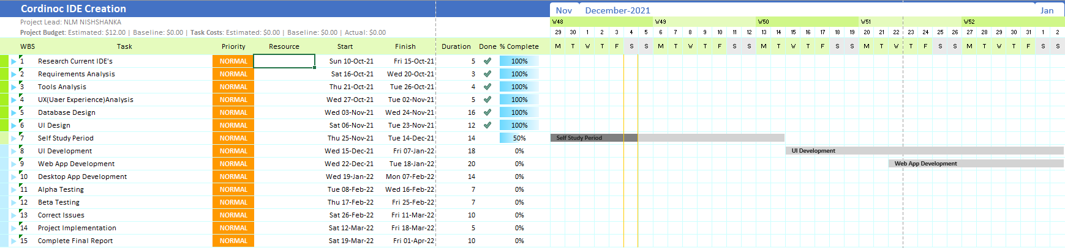

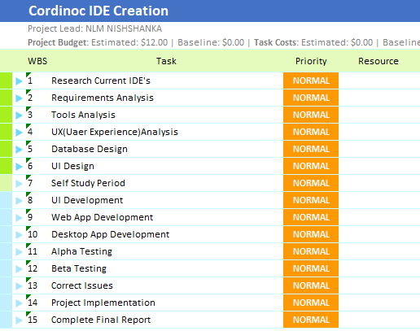

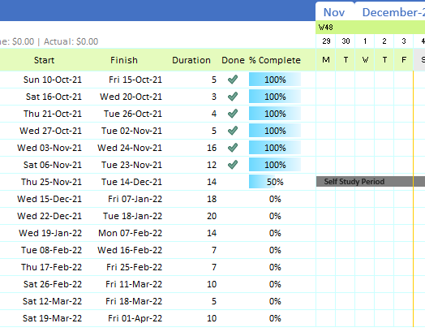

# Acknowledgements

* Hegde, R. and Karunakara, K., 2014. Improved Interaction in Web-Based Cloud IDE. Int. J. Innov. Technol. Explor. Eng., 4(4), pp.16-20.
* Arora, P., Dixit, A., BCIIT, D. and Noida, G., 2016. Analysis of cloud IDEs for software development. Int. J. Eng. Res. General Sci, 4(4).
* Hausladen, J., Pohn, B. and Horauer, M., 2014, September. A cloud-based integrated development environment for embedded systems. In 2014 IEEE/ASME 10th International Conference on Mechatronic and Embedded Systems and Applications (MESA) (pp. 1-5). IEEE.
* Aho, T., Ashraf, A., Englund, M., Katajamäki, J., Koskinen, J., Lautamäki, J., Nieminen, A., Porres, I. and Turunen, I., 2011. Designing IDE as a service. Communications of Cloud Software, 1(1).
* Jayasinghe, D.A.I., 2013. Secure IDE with Multi-user Workspace for Cloud Computing (SaaS) (Doctoral dissertation).
* Leisner, M. and Brune, P., 2019, May. Good-bye localhost: a cloud-based web IDE for teaching Java EE web development to non-computer science majors. In 2019 IEEE/ACM 41st International Conference on Software Engineering: Companion Proceedings (ICSE-Companion) (pp. 268-269). IEEE.
* Gadhikar, L.M., Mohan, L., Chaudhari, M., Sawant, P. and Bhusara, Y., 2013. Browser based IDE to code in the cloud. In New Paradigms in Internet Computing (pp. 59-69). Springer, Berlin, Heidelberg